# CS 255 System Design Document Template

This template lays out all the different sections that you need to complete for Project Two. Each section has guidance to prompt your thinking. You will need to continually reference the interview transcript as you work to make sure that you are addressing your client’s needs. There is no required length for the final document. Instead the goal is to complete each section based on what your client’s needs are. Remove this note when you are finished, and replace all bracketed text with the relevant information.

## UML Diagrams

### UML Use Case Diagram

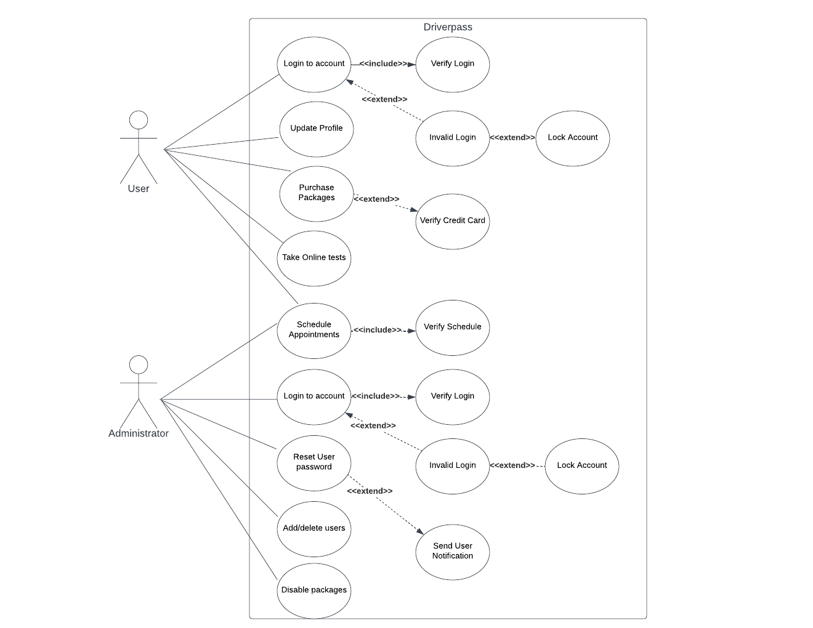

### UML Activity Diagrams

### UML Sequence Diagram

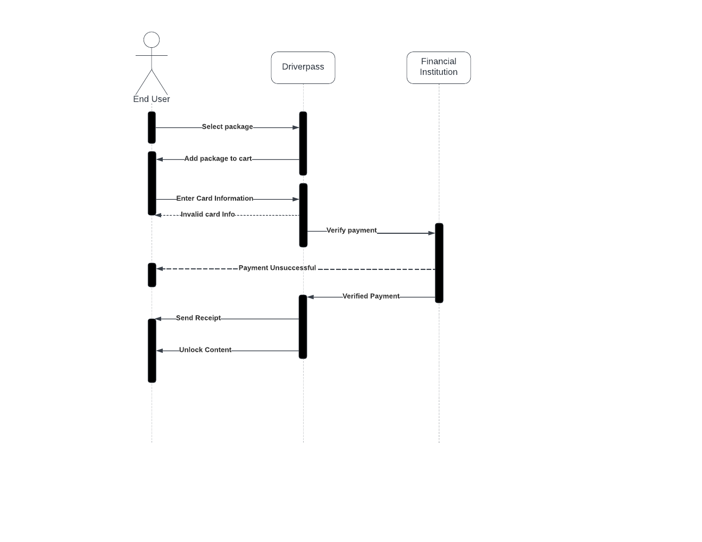

### UML Class Diagram

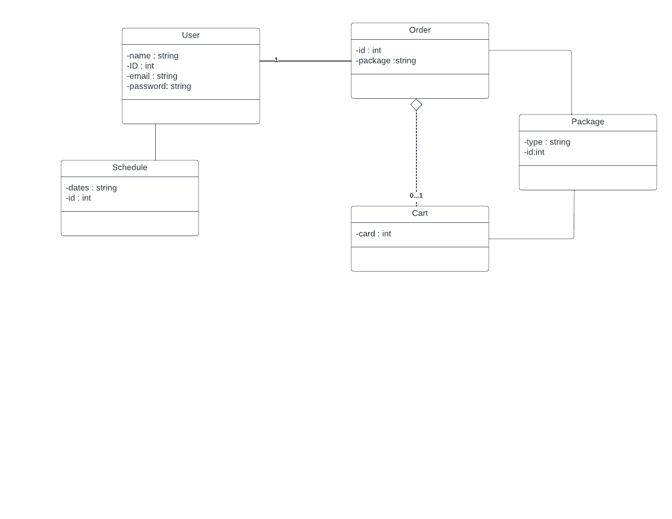

## Technical Requirements

The application will require a server to be available at all times, with the application being able to run on both desktops browsers (chrome, firefox, edge, etc.) and mobile devices (android and iOS). The application should preferably run on a cloud service, such as Azure or AWS, and include a database to manage user information on.